Established pursuant to Ordinance #1709 on 6/22/99 – name changed pursuant to Ordinance #1719, adopted by Board 3/28/00 – formerly “Tehama County Children and Families First Commission, established pursuant to Ordinance #1702 on 3/1/99 – Nine members: Board of Supervisors representative; Tehama County Department of Social Services Director; Tehama County Health Agency Director; Superintendent of the Tehama County Department of Education, each for no set term. Five Public at-large members (pursuant to Ordinance #1709 on 6/22/99), from any of the following categories: a) Recipients of project services included in the County strategic plan; b) Educators specializing in early childhood development; c) Local child care resource or referral agency or a local child care coordinating group; d) Local organization for prevention or early intervention for families at risk; e) Community-based organizations that have the goal of promotion nurturing and early childhood development; f) Local school districts; and g) Local medical, pediatric or obstetric associations or societies. Each position is for a three-year term, with the initial terms to be staggered, to expire 01/31/21, 01/31/22 and 01/31/23
Name & Address | Agency/Position/Affiliation  Email | Date of Original Appt. | Current Term Expires
Richard DuVarney  1135 Lincoln St. Red Bluff, CA 96080  (530) 528-7323 | Tehama County Department of  Education, County Superintendent of Schools  rduvarney@tehamaschools.org | 05/23/16 | NST
Laura Hawkins  310 Main St. (P O Box 1515), Red Bluff, CA 96080  (530) 528-4079 | Tehama County Department of  Social Services, Director  lhawkins@tcdss.org | 11/13/18 | NST
Candy Carlson  727 Oak St. (P O Box 250), Red Bluff, CA 96080  (530) 527-4655 x 3014 Cell (707) 578-3803 | Tehama County Board of Supervisors Representative  ccarlson@co.tehama.ca.us | 04/16/19 | NST
Valerie Lucero  818 Main St. (P O Box 400), Red Bluff, CA 96080  (530) 527-8491 x 3166 | Tehama County Health Agency, Executive Director  Valerie.Lucero@tchsa.net | 09/09/03 | NST
Anthony “Tony” F. Cardenas  958 Washington St., Red Bluff CA 96080  (530) 528-1395 | Public-At-Large Commission Member  Retired Corning Chief of Police  tonycardenas@comcast.net | 07/11/06 | 01/31/21
Sr. Pat Manoli  958 Washington St., Red Bluff CA 96080  (530) 528-1395 | Public-At-Large Commission Member  St. Elizabeth Community Hospital, Senior Director Community Health Services  patmanoli77@gmail.com | 02/01/11 | 01/31/23
Jennifer Torres  220 Sycamore St. Suite 200, Red Bluff CA 96080  (530) 529-1500 X 1139 | Public-At-Large Commission Member  NCCDI, Enrollment Manager  JTorres@nccdi.com | 02/26/19 | 01/31/23
Michelle Kinner  22630 Antelope Blvd., Red Bluff CA 96080  (530) 527-1272 | Public-At-Large Commission Member  Antelope Elementary, Program Specialist  Kinnermom3@gmail.com | 02/26/19 | 01/31/23
Kelsey King  958 Washington St., Red Bluff CA 96080  (530) 528-1395 | Public-At-Large Commission Member  Community Member  king.kelseym@gmail.com | 03/31/15 | 01/31/23
Commission Staff:
Heidi Mendenhall, Executive Director Angela Brinkman, Community Capacity Coordinator
hmendenhall@first5tehama.com abrinkman@first5tehama.com
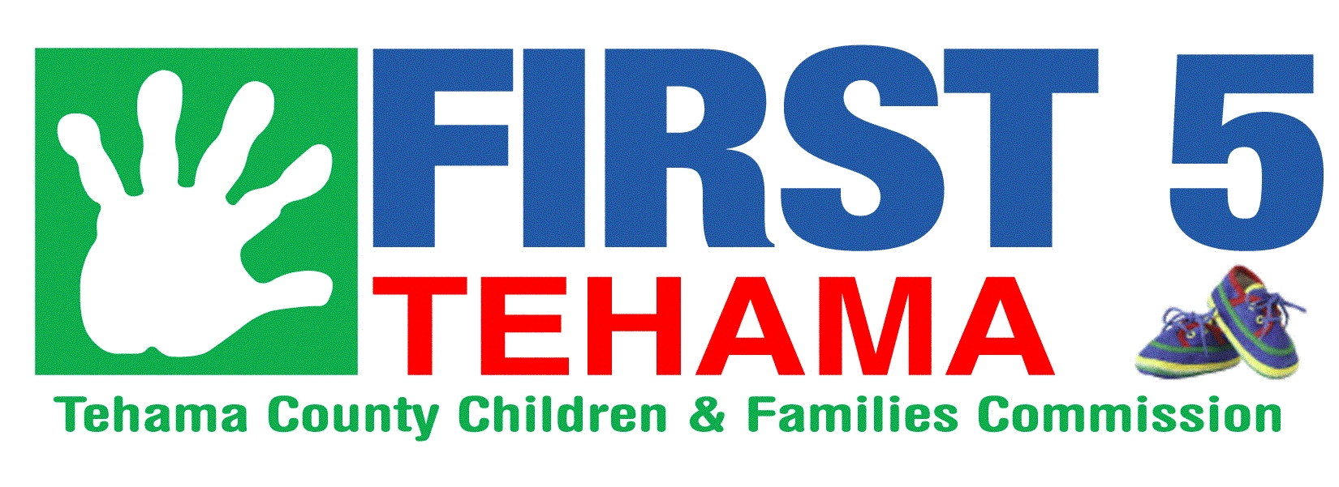

958 Washington St. (P. O. Box 858) Red Bluff CA 96080 (530) 528-1395

